INSTALLATION MANUAL

Ooyala Sharepoint PlugIn
Version 1.0
Index Table

Entries below are hyperlinked. Click on the required entry, to move to the page where it is dealt with.

Ooyala Sharepoint PlugIn Installation Manual 2
1 Document history 4
2 Scope 5
2.1 Overview 5
2.1.1 Why this Installer 5
2.1.2 Purpose of this guide 5
2.2 Known limitations / restrictions 5
3 Introduction 6
3.1 The Installer 6
3.2 Intended Readership 6
3.3 Applicability Statement 6
4 Overview – Application 6
4.1 Current scenario: 6
4.2 This installer: 6
5 Hardware & Software Requirements 8
6 Process at a Glance 9
7 Installation 10
8 Configuration 20
9 Share point site and page creation 20
9.1 Document Library Creation
21
9.2 Web Part Page Creation 22
10.2.1 API Settings 24
10.2.2 Label Taxonomy 26
10.2.3 Upload From Local 30
10.2.4 Upload From Share Point 33
10.2.5 Media Player Settings 35
10.2.6 Media Player 37
10.2.7 Detail View 38
10.2.8 Thumbnail View 40
9.3 Site Permission 43
9.4 Recommended Settings 43
10 Appendixes 44
10.1 Common Features 44

Document history
Edition | Date | Changes / Comments / Details
1 | 22nd Aug 2012

Scope

Overview

Why this Installer
This Installer is intended to automate the install process of OoyalaSharePoint.wsp file and configuration settings in Sharepoint.

Purpose of this guide
This guide is for the System Administrator only. This guide explains the setup and configuration of Sharepoint PlugIn. It also explains the method of installing its prerequisite applications and configuration.

Known limitations / restrictions

Introduction

The Installer

It allows you to easily install your solution files (*.wsp) on Share Point 2010 Farm, database and setting other configuration. It will analyze the required system softwares, permission and services before proceed to install. It will allow to create a new database and configure the media file type and file upload limit.

This installer consists below components
- WSP file
- Setup.exe
- Setup.config
- DB Script

Intended Readership
This manual is intended for the Sharepoint Administrator of the company. He should be in-charge for installing Share Point Plugin.

Applicability Statement
This manual is applicable for:
- Installing prerequisite software
- Sharepoint plugIn deployment
- Database connection and media file type configuration

Overview – Application
The purpose of this Installer is to automate the “.wsp” file installation, apply the database script and configuration settings.

Current scenario:
Without this installer, user needs to do by manually below things.
- Upload the “.wsp” file to sharepoint.
- Create a new database and apply the database scripts.
- Configuration settings for database connection and Media file type and Media file upload limit in web.config file.

This installer:
The installer can be launched with setup.exe, it will help us to find whether it required software installed, required services are started and solution already installed, if not installed any required software, it will show the red color indication. Also, it will help us to get the available data sources in the network from that user can select the particular data sources with proper credentials and then we can have options to select for create a new database or apply the database script for existing database.
It is help us to store the API key, Secret Key and Parent code with our local database. It will store the credentials based on proper validation with Ooyala. We can use our stored credentials for each and every request to Ooyala.
Also it will help us add the tags for connection string, Uploaded media file type and Uploaded media file size on web.config file.

Hardware & Software Requirements
The table below shows the minimum requirements for the Sharepoint Server.
Hardware Requirements

Processor | - 64 Bit, 4-Core
Memory | - 4 GB for stand alone or evaluation installation.  - 8 GB for single Server and multiple server farm installation for Production
Hard Disk | - 80 GB

Software Requirements

OS | - Windows Server 2008 R2
DB Servers | - Microsoft SQL Server 2008
.Net | - Microsoft Visual Studio 2010

Share Point 2010:

The following components can be automatically configured with SharePoint 2010. PrerequisiteInstaller.exe Tool
1. Role of Web Server (IIS)
2. Role of Application Server
3. Microsoft .Net Framework Ver 3.5 SP1
4. Microsoft Sync Framework Runtime 1.0(x64)
5. Microsoft Filter Pack 2.0
6. Microsoft Chart Controls for .Net Framework 3.5
7. Windows Power Shell 2.0
8. SQL Server 2008 Native Client
9. SQL Server 2008 Analysis Services ADOMD.Net
10. ADO.Net Data Services Update for .Net Framework 3.5 SP1
11. Windows Identity Foundation (WIF)

Browser : Need to Support Sharepoint Server 2010 - Silverlight 3

Process at a Glance
To get this installer working, below are the required steps:

- Unzip the file provided
⬇
- Give required inputs for Setup.exe.config file
⬇
- Run the setup file
⬇
- Give required database entries.
⬇
- Give Sharepoint Id, Ooyala credentials and validate.
⬇
- Select installation point
⬇
- Installation finished.

Following pages give details of the above points.

Installation
Copy the zip file: SharepointPlugIn-setup-kit.zip that is provided, to a directory. Unzip this file. When unzipped, the folder: SharepointPlugIn-setup-kit displays. Inside SharepointPlugIn-setup-kit folder, there is setup.exe, configuration, “.wsp” and DB script files will be there.
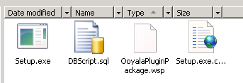Figure 1: Sharepoint PlugIn file structure

User need to get the solution id from OoyalaPlugInPackage.wsp file. So just make a another copy of OoyalaPlugInPackage.wsp file in same folder and change the file extension to “.zip”, now the file look like zip format. Right click the on zip file and click the extract to folder option.
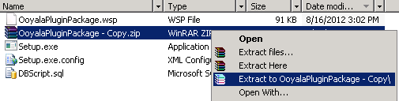Figure 1: Extract the zip file3
Open the extracted folder and right click on the “manifest.xml” and open up to note pad or any file. Now copy the solution id from the “manifest.xml”.
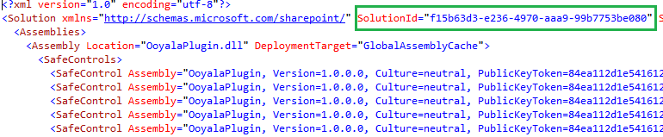Figure 3: Get the solution id
Open the Setup.exe.config file and fill the required information below.
- Locate the “Solution Id” and “SiteFeatureId” tag on Setup.exe.config file. Paste the copied value on 'Value' field.
- Locate the “SolutionFile” tag and specify the file name and path of “.wsp” file on 'Value' filed.
- Locate the “DBScriptFile” tag and specify the file name and path of “DBScript.sql” file on 'Value' filed.
- Locate the “OoyalaFileType” tag and specify the Media Asset file type with comma (,) separate.
- Locate the “OoyalaFileUploadLimitInMB” tag and specify the upload limit for Media asset files.
- Save and close the file.
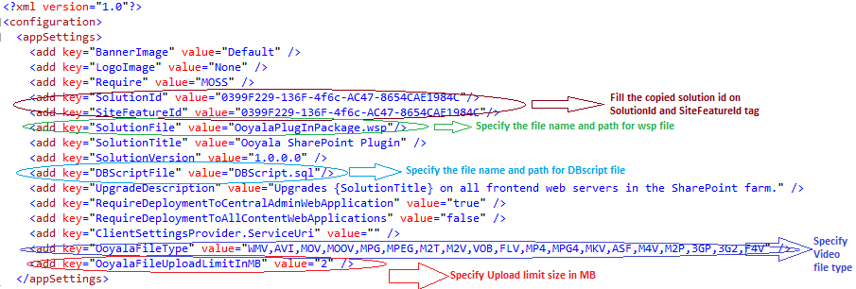Figure 4: Configuration file settings
Run the Setup File
Before run the 'Setup.exe' file ensure that all files(wsp, DB script) available in the mentioned path and configuration settings are proper.
Click and execute the 'Setup.exe' file, It will show the welcome form with title that is given on configuration file.
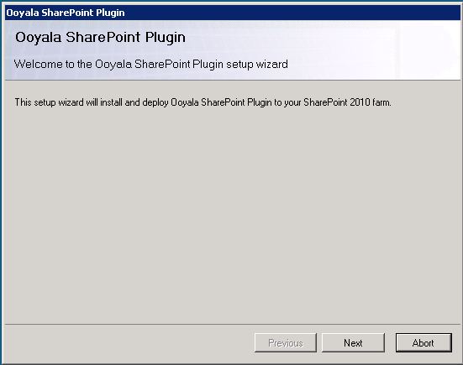
Click the “Next” button, it will show the 'System Check' form, it will automatically check the required softwares, services, permission and whether the solutions already installed.
Previous button: User can use the previous button to move previous form.
Abort button: User can use the Abort button to terminate the installation.
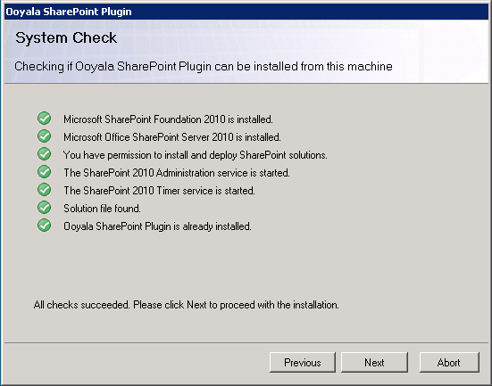
In the above screen shot, the green color tick icon indicate us the required softwares , services and permission and solutions are available for installation location, if it is so it is perfect for install the our wsp file. If indicate any red color icon, it is not suitable place for installation.
Once passes all above points, the user can navigate to next form.
If solution not already installed it will show the DB configuration form. If not installed skip the Data base configuration steps.
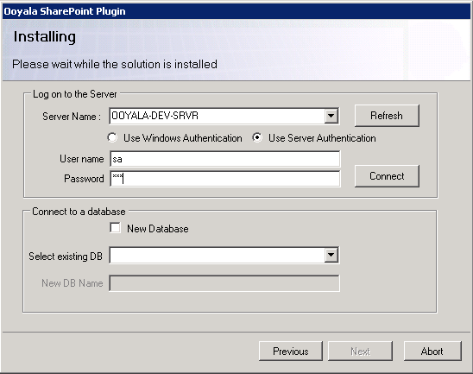
Follow the below steps to configure the Database setup.
- Select the server name that where user wants to apply the DB scripts
- Select the options for SQL login authentications. The credentials not required for Windows Authentication, the credentials required for if user select the Server Authentication.
- Click the “Connect” button. It will list the existing Data base in 'Existing DB' drop down list box.
- Here we have the two options to apply the DB script. User can apply the scripts for new data base or apply the scripts on Existing data base.
Applying the script on New database : Enable the 'New Database' check box and enter the name for new database on 'New DB Name' text box. Click the 'Create' button. The script will create a new DB named 'NewDB' and create new table for 'tblUser'.

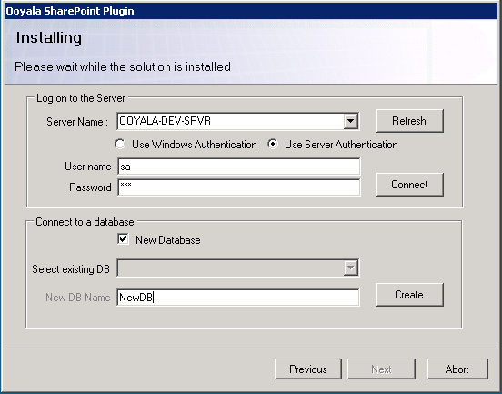
Applying the script on Existing database : Uncheck the 'New Database' check box and select the existing data base from 'existing DB' drop down list. Click the 'Create' button, it will create the 'tblUser'.
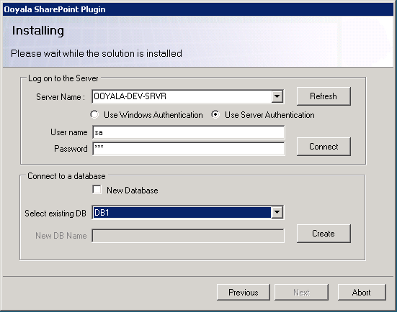
If solution already installed it will show the two options
- Repair : User can retracts the solution for all web applications and deploys it once again. If user wants to 'Repair' solution, select the Repair option and click the 'Next' button.
- Remove : Retracts the solution from all web applications and deletes it from the Share point solution store. If user wants to 'Remove' solution, select the Remove option and click the 'Next' button.
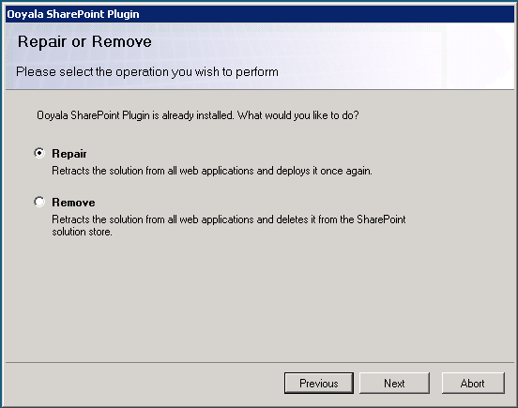
- Click the “Next” button, It will show the API Settings page. Here user wants to provide required details and click the save button. Once save the details user can click the next button.
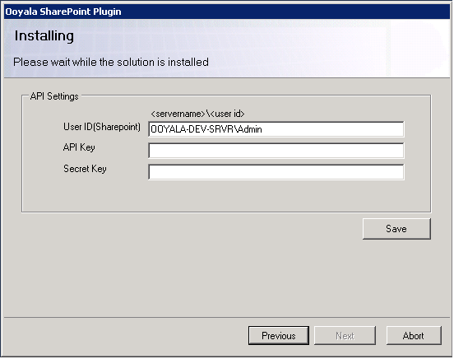
- It will open the 'Farm Deployment Target' form will appear. Please leave it is both selected. Click 'Next' button.
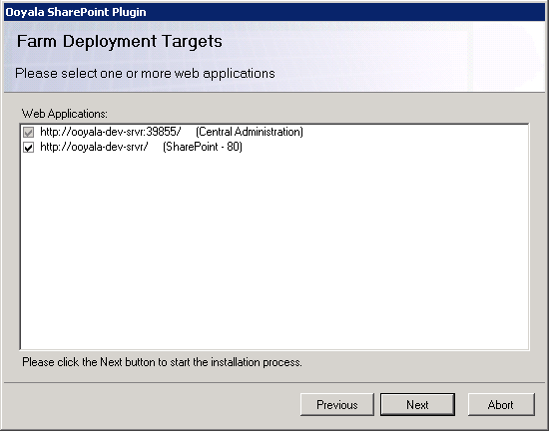
- It will show process of installation
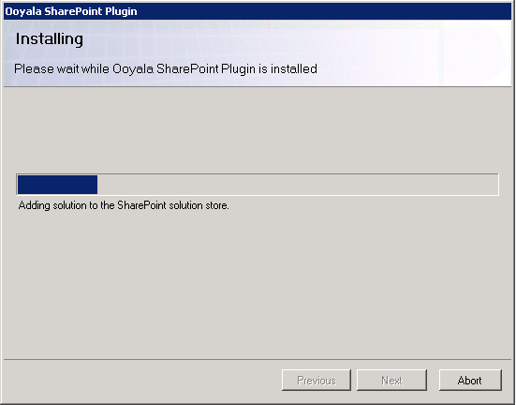
- Click the 'Next' button, it will show the “Installation successfully completed” form, close the form.
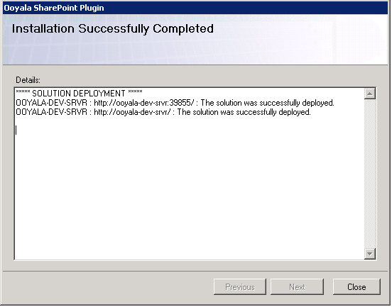

Configuration
The administrator can verify that whether our configuration settings has been applied successfullyon “C:\inetpub\wwwroot\wss\VirtualDirectories\80\web.config” file.
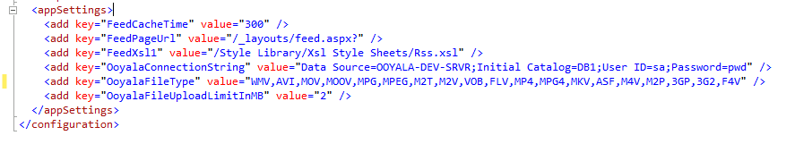
Open the file and verify the below details. If user wants to set the one more new file types or Upload limitation, we can add here or modify the value. No need to go for re installation process.

Share point site and page creation
Administrator should ensure that our features has been activated. Follow the below steps to activate the site features.

  - Login to Share point site with Administrator rights
  - Click the 'Site Action' button on top left of the site and click the 'Site Settings'

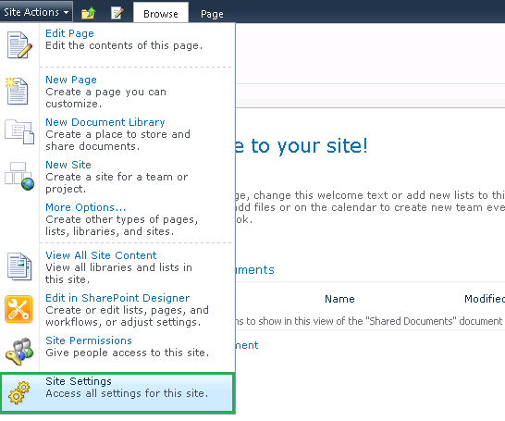
  - Find the 'Site collection Features' on 'Site Collection Administrator'
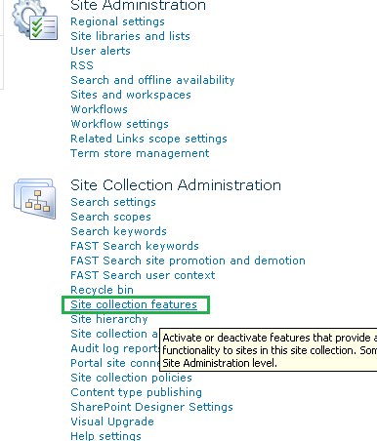
  - Ensure that whether our 'OoyalaPlugInFeature' has been activated, if not activate our 'OoyalaPlugInFeature'.

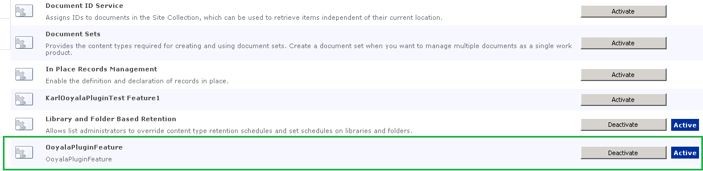
  - After activate the feature our web part will be available when adding a web part page.

Document Library Creation
Administrator wants to create library and add our web parts to web part page. Follow the below steps for create a library and add web part page.

Document Library Creation

- Login to share point site with administrator rights.
- Click the 'Site Action' button on top left corner, and then select 'More options'
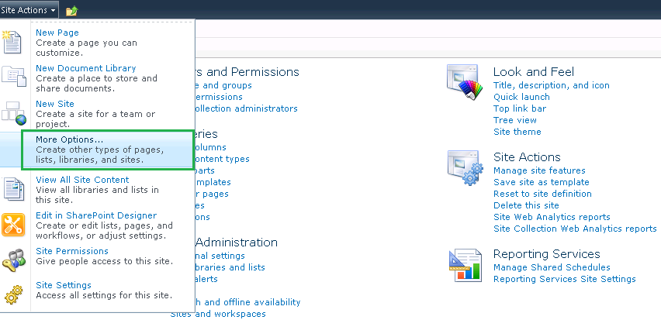
- Select the library->Document Library and enter the name 'OoyalaPlugIn' then click the 'Create' button.

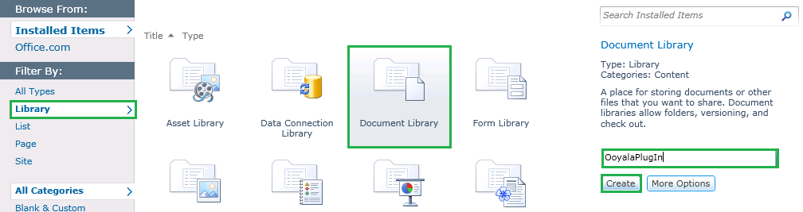
- Click the home link and see the newly created 'OoyalaPlugIn' library link.

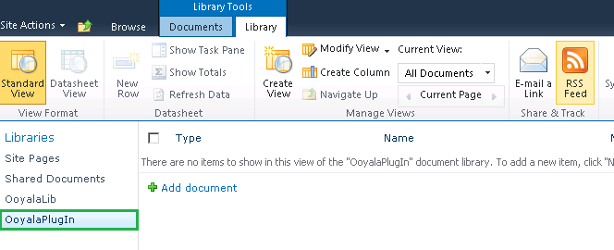
Web Part Page Creation

We can create separate page each web parts. Follow the below steps for web part page creation

We have 8 web parts :

1) API Settings
2) Label Taxonomy
3) Upload From Local
4) Upload From Share Point
5) Media Player Settings
6) Media Player
7) Thumbnail View
8) Detail View

Common steps for create each web part :

- Login to Share point site with Administrator rights.
- Click the 'Site Action' button on top left corner and select the more options.

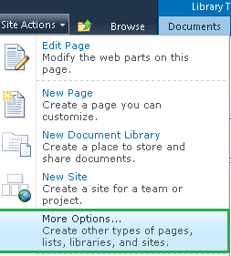
- Select Page->Web part page → click the 'Create' button

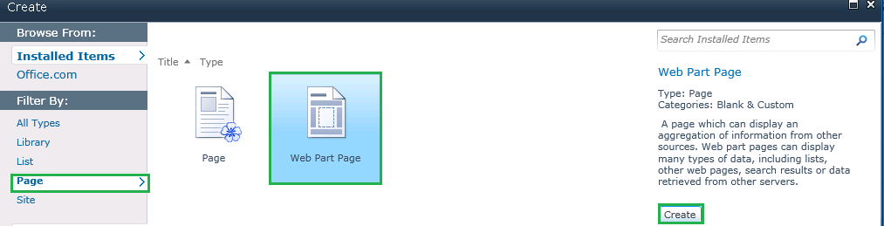

- It will navigate to another page, there user needs to give name for web part page. For example I am creating API Settings web part page, the name should API settings and then select the document library to save this web part.
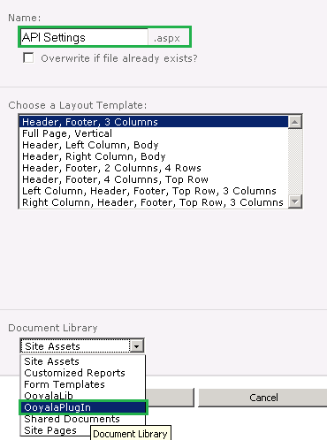
- Click create button, it will navigate to 'Add web part' page.

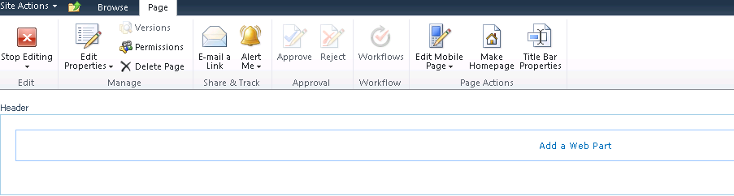

10.2.1 API Settings

Follow the “Common steps for create each web part” steps before add the API settings web part.

- Go to the 5th steps, click the 'Add a Web Part' link.

- Select the “OoyalaPlugin' folder -> 'API Settings' web part and then click the 'Add' button.
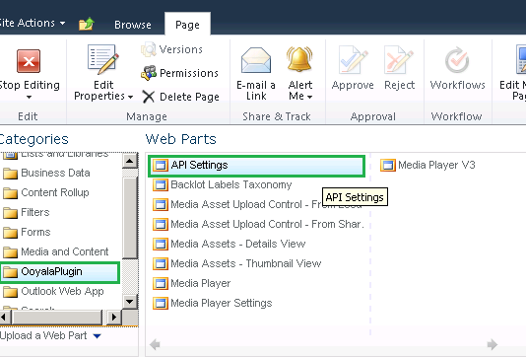
- Click the stop editing button.

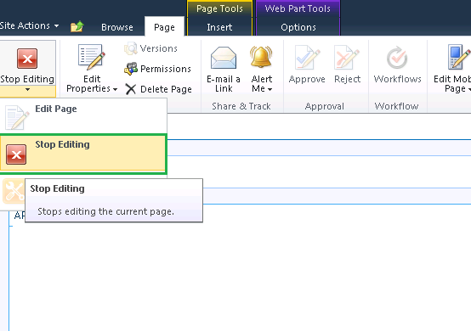
- Click the 'Site Action' and select the 'View All Site Contents” and then select “OoyalaPlugIn” from the list.
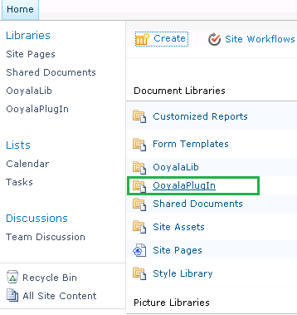
- Click the “Home”-> “OoyalaPlugIn” ->”API Settings”

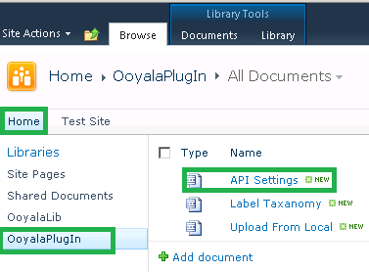
- The API settings web part page will show in right side.

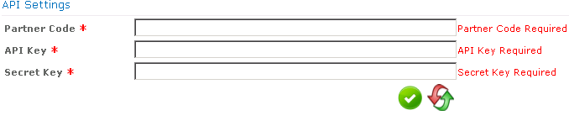

10.2.2 Label Taxonomy

Follow the “Common steps for create each web part” steps before add the Label Taxonomy web part.

- Go to 4th steps of the “Common steps for create each web part”, Enter the name for web part page as “Label Taxonomy”.

- Click the 'Add web part” and select the “OoyalaPlugIn-> Backlot Lable Taxonomy”

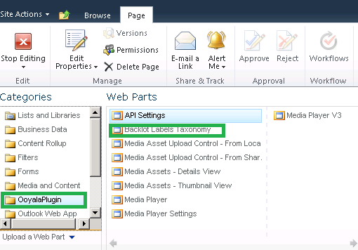
- hover the mouse on right side of the web part, you can find small rectangle icon will appear, click the icon and select 'Edit Web Part”.

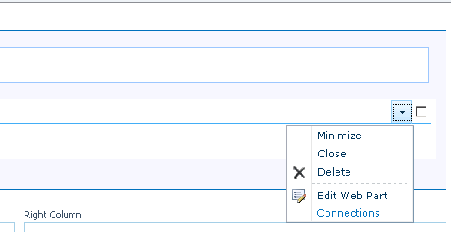
- Right side the edit web part window will appear, there you can drill down the “Backlot Label Taxonomy” and enable the functionality what you want.

Allow Add New Labels –Add icon will be enabled and user can add the labels.
Allow Edit Labels - Edit icon will be enabled, user can edit the labels.
Allow Delete Labels - Delete icon will be enabled, user can delete the labels.

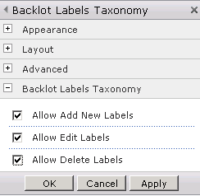
- Click “Apply” and “OK” and Stop Editing button.

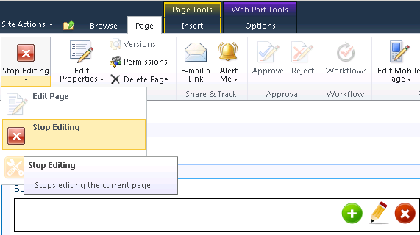
- Click “Site Action” and select “View All Site Content”.

- Select 'Ooyala PlugIn” from list.

- Select the “OoyalaPlugIn” → “Lable Taxonomy”.

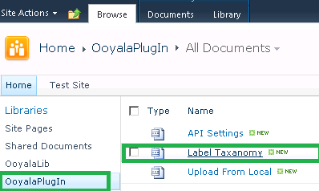
- Now you can see the “Label Taxonomy” page on right side.

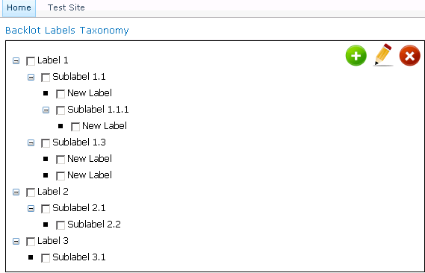

10.2.3 Upload From Local
This web part will help to us to upload the “Media Asset” from local computer.

- Go to 4th steps of the “Common steps for create each web part”, Enter the name for web part page as “Upload From Local”.

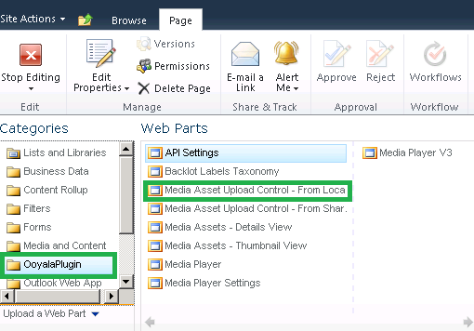
- Click the 'Add web part” and select the “OoyalaPlugIn-> Media Asset Upload Control – From Local computer” and then click “Add” button.

- hover the mouse on right side of the web part, you can find small rectangle icon will appear, click the icon and select 'Edit Web Part”.

- Locate the right side 'Edit Web Part” window, drill down the “Media Upload Control” and select the options you want.
Allow Custom Metadata – On of Off option based on that user can enter the Custom Meta data.
Allow Labels - On of Off option based on that user can tag the Media asset with Labels data.

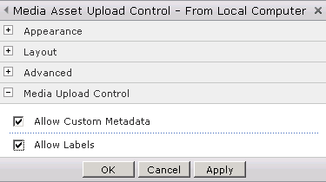
- Stop Editing and Click the 'Site Action” and Select the “View All Site Content”.

- Select the “OoyalaPlugIn” from the list.

- Select the “Upload From Local” page and see the out put on right side.

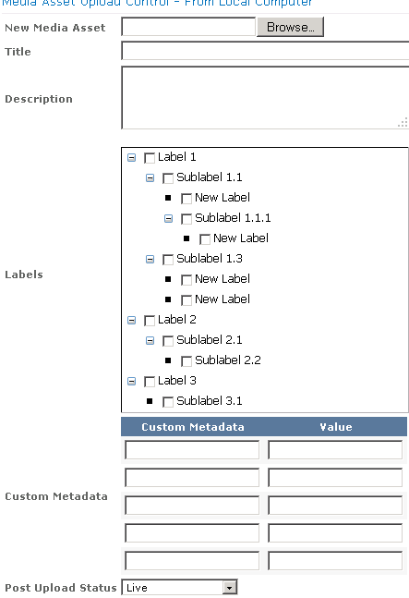

10.2.4 Upload From Share Point
This web part will help to us to upload the “Media Asset” from share point.

- Go to 4th steps of the “Common steps for create each web part”, Enter the name for web part page as “Upload From SharePoint”.

- Click the Add Web part link and select the “Media Asset Upload Control – From Sharepoint” web part.

- hover the mouse on right side of the web part, you can find small rectangle icon will appear, click the icon and select 'Edit Web Part”.

- Locate the right side 'Edit Web Part” window, drill down the “Media Upload Control” and select the options you want.
Allow Custom Metadata – On of Off option based on that user can enter the Custom Meta data.
Allow Labels - On of Off option based on that user can tag the Media asset with Labels data.

- Click 'Apply' and 'Ok' button and Stop Editing and Click the 'Site Action” and Select the “View All Site Content”.

- Select the “OoyalaPlugIn” from the list.

- Select the “Upload From Sharepoint” page and see the out put on right side.
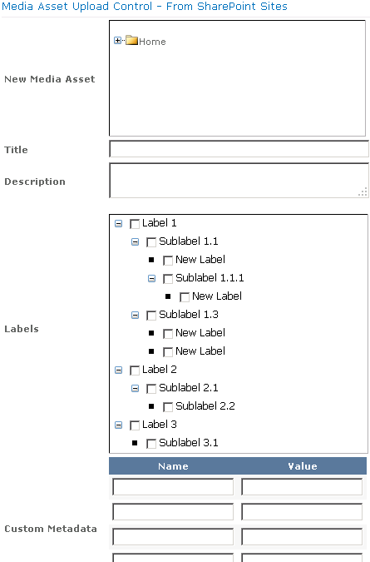

10.2.5 Media Player Settings
This web part will help us set the properties for Media Player.

- Go to 4th steps of the “Common steps for create each web part”, Enter the name for web part page as “Media Player Settings”.

- Click the Add Web part link and select the “Media Player Settings” web part.

- hover the mouse on right side of the web part, you can find small rectangle icon will appear, click the icon and select 'Edit Web Part”.

- Locate the right side 'Edit Web Part” window, drill down the “Media Upload Control” and select the options you want.
Allow Add New Player – User can add new Media Player.
Allow Edit New Player - User can Edit the Media Player Settings.
Allow Delete New Player - User can Delete the Media Player Settings.

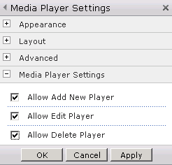
- Click 'Apply' and 'Ok' button and Stop Editing and Click the 'Site Action” and Select the “View All Site Content”.

- Select the “OoyalaPlugIn” from the list.

- Select the “OolayaPlugIn” → “Media Player Settings”

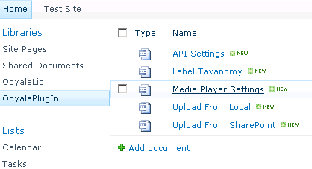
- The final output of Media player settings web part will display on right side.

10.2.6 Media Player
This web part will help to us to view the video based on player selection.

- Go to 4th steps of the “Common steps for create each web part”, Enter the name for web part page as “Media Player”.

- Click the Add Web part link and select the OoyalaPlugIn → “Media Player V3” web part.

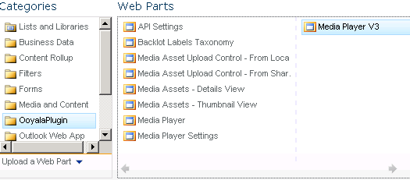
- Stop Editing and Click the 'Site Action” and Select the “View All Site Content”.

- Select the “OoyalaPlugIn” from the list.

- Select the “OoyalaPlugin” - > “Media Player”.

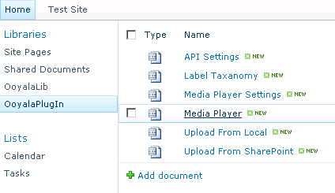
- The Media player will display on right side.

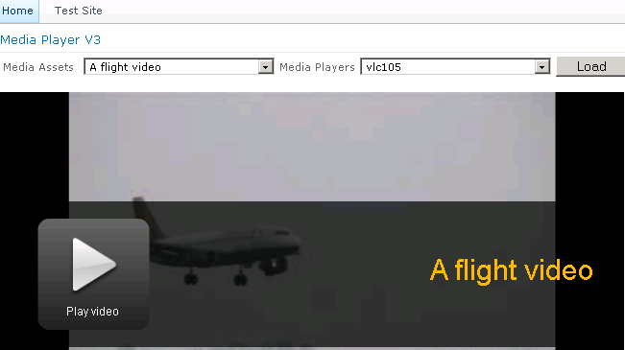

10.2.7 Detail View

This web part will help to us to view, edit and delete the listed asset based on search conditions.

- Go to 4th steps of the “Common steps for create each web part”, Enter the name for web part page as “Detail View”.
- Click the Add Web part link and select the OoyalaPlugIn → “Media Asset Detail View” web part.

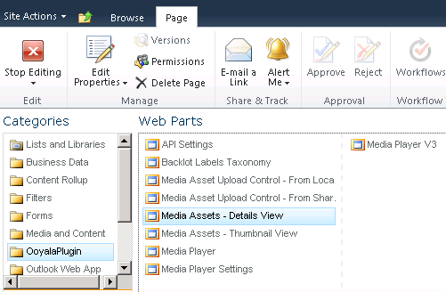
- hover the mouse on right side of the web part, you can find small rectangle icon will appear, click the icon and select 'Edit Web Part”.

- Locate the right side 'Edit Web Part” window, drill down the “Media Asset Detail View” and select the options you want.
Show Search – Enabling this, user can view the Search panel.
Page Limit- User can set the page limit for their convenient.
Show Custom Meta data – Enabling this user can see the custom meta data information
Allow Labels - Enabling this option user can see the label and tag the Media with this.
Allow Edit – Edit the Media asset detail by enable this option.
Allow Delete – User can delete the Media Asset by enabling this option.

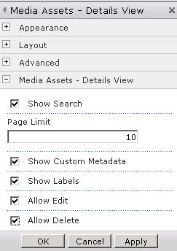
- Click 'Apply', 'Ok' button. Stop Editing and Click the 'Site Action” -> Select the “View All Site Content”.

- Select the “OoyalaPlugIn” from the list.

- Select the “OoyalaPlugIn” → “Detail View”

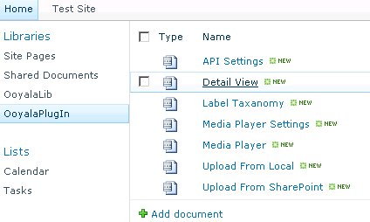
- The detail View page will display on right side.

10.2.8 Thumbnail View

This web part will help to us view the Media asset image in Thumbnail view, it will show based on search conditions.

- Go to 4th steps of the “Common steps for create each web part”, Enter the name for web part page as “Thumbnail View”.

- Click the Add Web part link and select the OoyalaPlugIn → “Media Asset Thumbnail View” web part.

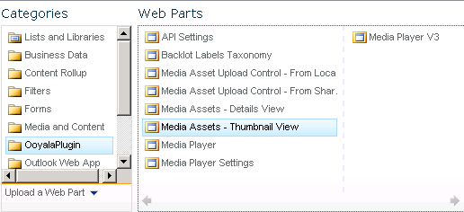
- hover the mouse on right side of the web part, you can find small rectangle icon will appear, click the icon and select 'Edit Web Part”.

- Locate the right side 'Edit Web Part” window, drill down the “Media Asset Thumbnail View” and select the options you want.
Show Search – Enabling this, user can view the Search panel.
No of Columns/Page- User can set the column size for their convenient.
No of Rows – User can set the row size for their convenient.

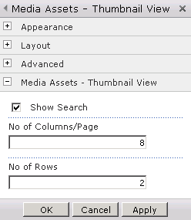
- Click 'Apply', 'Ok' button. Stop Editing and Click the 'Site Action” -> Select the “View All Site Content”.

- Select the “OoyalaPlugIn” from the list.

- Select the OoyalaPlugIn-> ThumbnailView

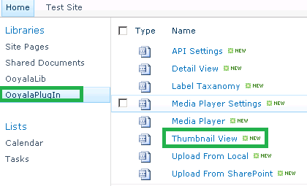
- The thumbnail view page will display on right side.

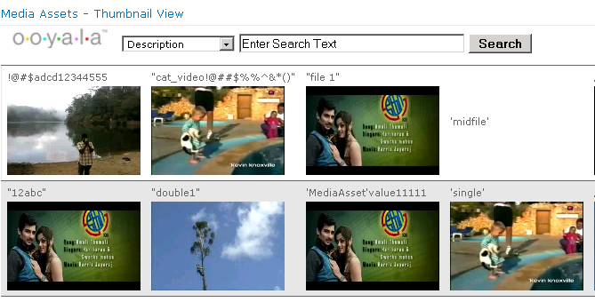

Site Permission
All web parts will work based on Administration rights and Full control, Design user permissions.

Recommended Settings
1) Sharepoint allowing to upload upto 2GB(2147483647 bytes)
Increase the maximum upload size
- Click Start, point to All Programs, point to Administrative Tools, and then click SharePoint Central Administration. Then, click Application Management.
- Under SharePoint Web Application Management, click Web application general settings.
- On the Web Application General Settings page, click the Web application that you want to change.
- Under Maximum upload size, type the maximum file size in megabytes that you want, and then click OK. You can specify a maximum file size up to 2,047 megabytes.
2) Change the configuration settings for Max request length and executionTimeout at httpRuntime tag in “C:\Inetpub\wwwroot\wss\VirtualDirectories\80\web.config”. Default executionTimeout is 120, it can be extendable up to 60000 seconds. So we can set it up to 3600 seconds(60 mins). These configuration will help to upload the Asset from Local system with out any Max request length problem and Time out problem. Need to change the yellow shaded tag.
Existing tag :
<customErrors mode="Off" />
<httpRuntime maxRequestLength="51200" />
<authentication mode="Windows" />
<identity impersonate="true" />

Modified tag:
<customErrors mode="Off" />
<httpRuntime maxRequestLength="2097151" executionTimeout="3600" />
<authentication mode="Windows" />
<identity impersonate="true" />

Appendixes

Common Features
- Outline numbering is followed throughout this guide
- To indicate emphasis or to distinguish objects in a sentence, they are given Bold formatting.
- As much as possible, screen shots are provided to visualize actual displays
- The screen shots do not necessarily show the complete screen. They display only the relevant part of the screen.

